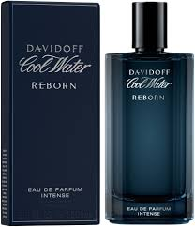
DAVID OFF PERFUME
Product Overview
Davidoff fragrance is crafted for the modern man who values confidence and sophistication. With its refreshing aquatic and woody notes, it delivers a bold yet smooth aroma that energizes your senses. Perfect for both daytime freshness and evening elegance, this scent leaves a lasting impression wherever you go.
Key Features
* Brand: Davidoff
* Category: Men
* Volume: 200ml
* Fragrance Type: Eau De Toilette
* Long-lasting performance (6–8 hours)
* Ideal for office and special occasions
Pricing
Old Price: Rs. 2500
Discounted Price: Rs. 2250

